**Project Planning using Agile methodologies**

**Sprint Delivery Plan**

|  |  |
| --- | --- |
| Date | 19 September 2022 |
| Team ID | PNT2022TMID43270 |
| Project Name | Signs with smart connectivity for better road safety |
| Maximum Name | 2 Marks |

**Abstract**

The Safe System (SS) approach to road safety emphasizes safety-by-design through ensuring safe vehicles, road networks, and road users. With a strong motivation from the World Health Organization (WHO), this approach is increasingly adopted worldwide. Considerations in SS, however, are made for the medium-to-long term. Our interest in this work is to complement the approach with a short-to-medium term dynamic assessment of road safety. Toward this end, we introduce a novel, cost-effective Internet of Things (IoT) architecture that facilitates the realization of a robust and dynamic computational core in assessing the safety of a road network and its elements. In doing so, we introduce a new, meaningful, and scalable metric for assessing road safety.

We also showcase the use of machine learning in the design of the metric computation core through a novel application of Hidden Markov Models (HMMs). Finally, the impact of the proposed architecture is demonstrated through an application to safety-based route planning.

**1. Introduction**

Its Global Status Report on Road Safety – 2015, the World Health Organization (WHO) noted that the worldwide total number of road traffic deaths has plateaued at 1.25 million per year, with tens of million either injured or disabled [1]. Different initiatives, such as the United Nations’ initiative for the 2011-2020 Decade of Action for Road Safety, have led to improvements in road safety policies and enforcements. However, the WHO notes that the progress has been slow and has maintained the call for urgent action to reduce these figures [2].

Add to the losses in human lives and wellbeing, considerable monetary losses are incurred in medical expenses, infrastructure repair, and production downtime. While the worldwide figures have plateaued, the Global Status Report does indicate higher road fatalities and injuries in low-income countries. Such disparity, as noted in [3], signals a barring-limitation in low-income countries to improve road-safety by adopting solutions implemented in high-income countries.

The WHO describes different measures that can be implemented with minimal economic impacts in its “Save LIVES: Road Safety Technical Package” [4]. A cornerstone of these steps is realizing economic systems for “monitoring road safety by strengthening data systems”. Meanwhile, a key theme in the package is motivating the adoption of a Safe System approach, which is a holistic approach to road safety that parts from traditional management solutions by emphasizing safety-by-design.

**1.1. The Safe System Approach**

The Safe System (SS) approach to transport networks originated with the “Safe Road Transport System” model developed by the Swedish Transport Agency. In its essence, the approach migrates from the view

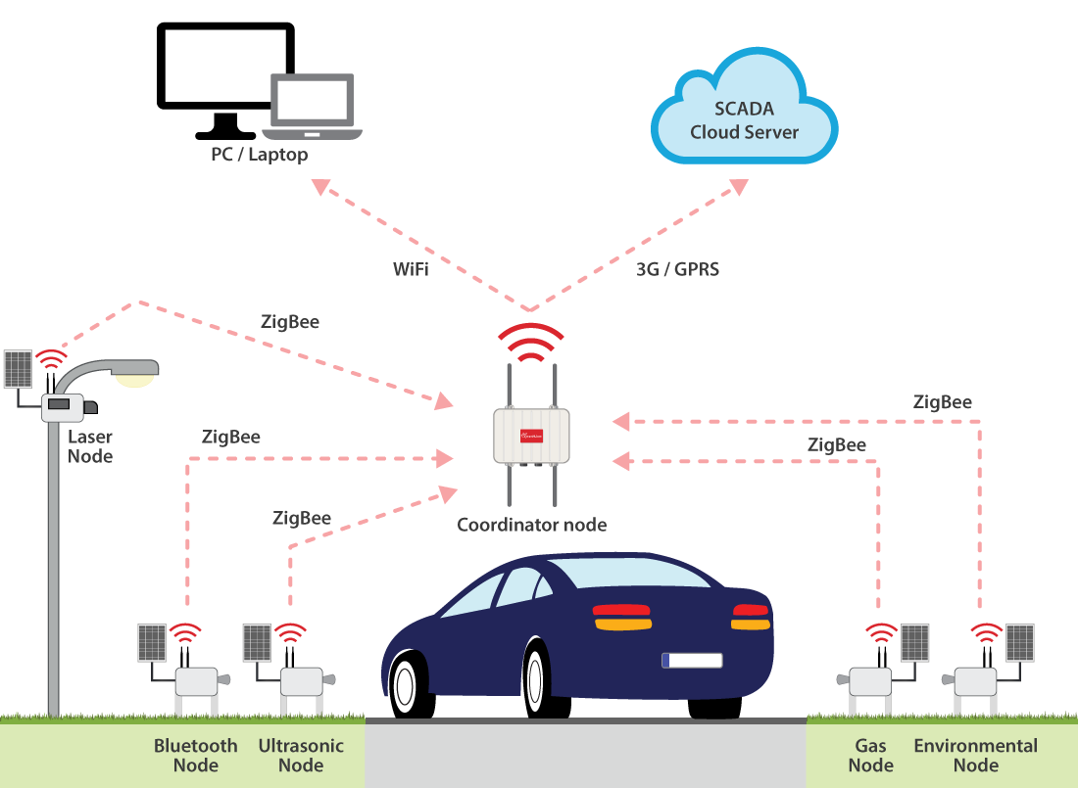

**One of the key features of UIS is vehicle identification.** Bluetooth nodes acquire the MAC (Media Access Control) of Bluetooth devices located in vehicles traveling on the selected urban area. The Bluetooth node detects also the device type (mobile phones, hands free, laptop, etc.).

In this way, the MAC address of a particular Bluetooth device is unique, so it can be used to identify the vehicle carrying the Bluetooth device. The car tracing can be possible through the detection of the same MAC by different Bluetooth nodes of the UIS platform. If a difference of time exists between different intervals of detected Bluetooth with the same MAC, then a trip between a certain origin-destination pair has been identified.

This process is used **to calculate the Origin-Destination matrix**. The O-D matrix is a powerful tool for traffic management, containing the information about the way vehicles are moving between different points of interest. It is noteworthy that**privacy rights are preserved**, since MAC addresses are not linked to any individual.

**A powerful tool for city managers**

This project presents a **wireless sensor network designed to characterize urban traffic parameters**. In particular, vehicle counting and identification are the key to obtain information about origins and destination of trips in the area under study.

This data allows the **calculation of the origin-destination matrix in real time**, providing city managers with a powerful tool to adapt traffic planning to real demands. Up to now this matrix required an extensive field work linked to roadside interviews and needing weeks or months to be completed.

**The system has been validated in real conditions**. Transmitter nodes have been tested separately and data about detection using ultrasound and Bluetooth have been obtained. The complete system have also carried out proving its capability to calculate an origin-destination matrix in real time, with acceptable accuracy.

The UIS is possible to be deployed by a wider geographical area, as a city. Besides, calculations can be refreshed in real time through the SCADA system, **allowing traffic managers to obtain an information that up to this moment required weeks or months.**

